Adel shurab 21023153

Question: Mac needs to find the area of its halls. all halls are square in shape.
They write the following code
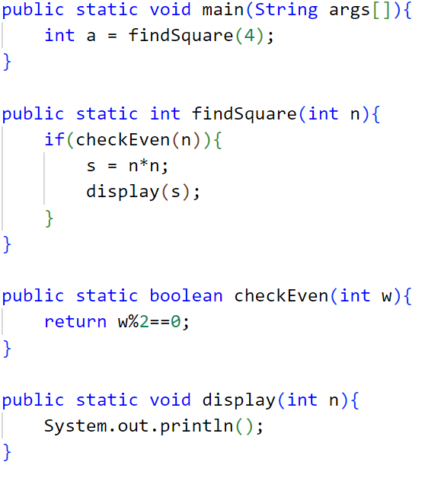
SHOW how the memory stack will be used at the execution of this code

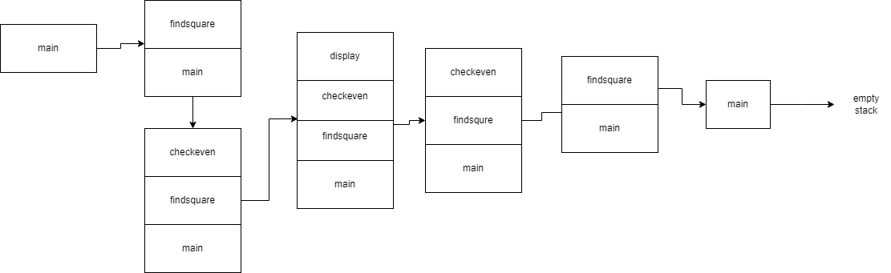

After the code execution is completed, the memory stack is in the following state:

The main method's stack frame has been removed from the stack.
The findSquare function's stack frame has been taken out of the stack.
The checkEven method's stack frame has been removed from the stack.
The show method's stack frame has been popped out of the stack.
The display method's stack frame has been removed from the stack.
Finally, the stack is empty as there are no more active stack frames.
the stack has been emptied, indicating that all the function calls have finished executing and their respective stack frames have been removed in a last-in, first-out manner.

